

**UNIVERSITY OF GHANA**

**COLLEGE OF BASIC AND APPLIED SCIENCES**

**SCHOOL OF ENGINEERING SCIENCES**

**DEPARTMENT OF COMPUTER ENGINEERING**

GROUP 6

Waqas Haaris Ali - 10947015

Saani Mustapha Deishini - 10978425

Boniface Delali Dakey - 10969344

Michael Kwabena Adu-Gyamfi - 10980219

Felix Yaw Azaglo - 10951571

**Development of an Autonomous Track-Following Car**

Report submission date: 16th February 2024

Table of Contents

**Acknowledgements** 3

**Executive Summary** 3

**Introduction** 3

**Tasks Accomplishments and Knowledge Acquisition:** 4

Hardware Assembly 4

Software Development: 4

System Integration: 4

**Materials and Resources:** 4

Hardware 4

Software 4

**Challenges and Professional Experience:** 5

**Potential Industry Problem for Solution as Final Year Project** 5

**Description of the Problem:** 5

**How the Problem was Identified:** 5

**Consideration of the Problem:** 5

**Benefits of the Solution to the Industry:** 6

**Conclusion and Recommendation** 7

**Conclusion:** 7

**Recommendation:** 7

**Benefits of Project to Studies:** 7

**References** 8

**Appendices** 8

**Appendix 1: Weekly Activities** 8

Week 1: 8

Week 2: 8

**Appenedix 2 : Pictures** 9

# **Acknowledgements**

We extend our heartfelt gratitude to Dr. Margaret Richardson, who provided us with guidance and also the circuit board for the execution of the autonomous track-following car project.

We are also profoundly thankful to TA Moses whose assistance and feedback were crucial in overcoming the technical challenges encountered during the project.

# **Executive Summary**

This report details the project focused on developing an autonomous car that navigates a defined path using white lines on a track. The project utilized a combination of hardware and software technologies, including the STM32 Nucleo board for core processing tasks, a Raspberry Pi for higher-level decision-making and processing, and a camera for real-time track visualization and navigation. The objective was to showcase the integration of embedded systems and computer vision in creating a practical autonomous vehicle model. Significant achievements included successful track navigation under varying lighting conditions and the development of an efficient algorithm for path detection and adjustment. This project not only demonstrated the technical capabilities of combining different technologies but also highlighted potential areas for further research and development in autonomous vehicle systems. The experience gained from this project has provided invaluable insights into the practical applications of embedded systems and computer vision, opening avenues for future projects in autonomous vehicle technology.

# **Introduction**

Our project embarked on the development of an autonomous vehicle capable of navigating a predefined track, leveraging the synergistic potential of embedded systems and computer vision technologies. This initiative stemmed from a shared enthusiasm among team members for exploring the intricate realms of robotics and the practical applications of autonomous navigation. The core objective was to design, build, and program a car that could autonomously follow a track outlined on a white surface, incorporating a STM32 Nucleo board for control logic, a Raspberry Pi for processing, and a camera for real-time track visualization.

This endeavor was not only a testament to our collective interest in the dynamic field of embedded systems but also served as a pivotal educational experience, aligning closely with our academic and professional aspirations in computer engineering. By undertaking this project, we aimed to bridge theoretical knowledge with practical application, enhancing our understanding of embedded systems, robotics, and computer vision. Furthermore, it provided a valuable opportunity to cultivate teamwork, problem-solving, and technical skills essential for our future careers in technology and engineering.

# **Tasks Accomplishments and Knowledge Acquisition:**

Our project aimed to create an autonomous vehicle that could navigate a predefined track marked on a white surface. The development process began with the conceptualization phase, where we brainstormed the design and functionality of the car, followed by the selection of appropriate technologies and components. We divided the project into three main tasks: hardware assembly, software development, and system integration.

Hardware Assembly: We meticulously assembled the car using a chassis kit, attaching motors for movement, a STM32 Nucleo board as the central control unit, and a Raspberry Pi for higher-level processing. The camera was mounted at the front of the car to capture real-time images of the track.

Software Development: The programming of the STM32 Nucleo board involved writing firmware to control the motors based on input signals. For the Raspberry Pi, we developed a Python script that utilized computer vision algorithms to process the camera's input, recognize the track, and determine the steering direction. We implemented algorithms for image segmentation and edge detection to distinguish the white track from the surrounding area.

System Integration: The final stage involved integrating the hardware and software components, ensuring seamless communication between the Raspberry Pi and the STM32 Nucleo board. This required careful calibration of the sensor inputs and fine-tuning of the control algorithms to achieve smooth and accurate track following.

# **Materials and Resources:**

Hardware: Raspberry Pi, camera, chassis kit, motors, breadboard, jumper wires, arduiono Uno R3, hw 130 motor shield, stm32h743z12

Software: Embedded C for STM32 programming, Python for Raspberry Pi, OpenCV library for computer vision.

# **Challenges and Professional Experience:**

One of the major challenges we faced was optimizing the computer vision algorithm for real-time track detection under varying lighting conditions. This required extensive experimentation with different image processing techniques and parameters. Another challenge was achieving precise motor control to navigate tight curves on the track, which necessitated multiple iterations of PID control tuning.

Overcoming these challenges was a highly rewarding experience, enhancing our skills in embedded systems programming, computer vision, and robotics. Collaborating as a team, we learned to combine our diverse expertise, communicate effectively, and manage project timelines efficiently. This project not only broadened our technical knowledge but also provided invaluable insights into the practical challenges and complexities of developing autonomous systems.

Also, in the middle of testing, the STM32 Nucleo board got burned, as a result of a miscalculated voltage used. Hence, it was replaced with an Arduino Uno board.

This project represented a significant milestone in our academic and professional development, offering a hands-on experience that bridged the gap between theoretical concepts and their real-world applications. It has equipped us with a solid foundation in embedded systems and autonomous vehicle technology, preparing us for future challenges in the engineering field.

# **Potential Industry Problem for Solution as Final Year Project**

## **Description of the Problem:**

During the development of the autonomous track-following car, it became evident that scalability and optimization pose significant challenges in the realm of autonomous vehicle systems. These issues are crucial in transitioning from controlled environments to real-world applications, where variables and conditions are more complex and unpredictable.

## **How the Problem was Identified:**

The identification of scalability and optimization issues emerged through rigorous testing and development of the track-following car. The project's limitations highlighted the difficulties in adapting similar technologies for broader, more dynamic environments without compromising efficiency and reliability.

## **Consideration of the Problem:**

This problem warrants serious consideration due to its potential impact on the deployment of autonomous vehicles on a larger scale. The complexities of real-world navigation, including varying track conditions, obstacles, and dynamic changes in the environment, underscore the need for advanced solutions that can adapt and scale without significant losses in performance.

# **Benefits of the Solution to the Industry:**

Addressing these scalability and optimization challenges could lead to significant advancements in autonomous vehicle technology. Solutions that enhance the efficiency and reliability of these systems can pave the way for safer, more dependable autonomous transportation options. Furthermore, improvements in this area could contribute to the broader adoption of autonomous vehicles, revolutionizing the way we think about transportation, reducing human error, and increasing safety on our roads.

# **Conclusion and Recommendation**

## **Conclusion:**

The project experience provided a profound opportunity to apply theoretical knowledge to a practical challenge, resulting in the successful development of an autonomous track-following car. This project, which integrated a STM32 Nucleo board, Raspberry Pi, and a camera, not only enhanced my understanding of embedded systems and computer vision but also honed my problem-solving and project management skills. The hands-on experience with hardware and software tools, coupled with the challenges faced and overcome, has been invaluable in bridging the gap between classroom learning and real-world application.

## **Recommendation:**

Based on the learnings and outcomes of this project, We recommend the following for future research or development in this area:

Advanced Algorithm Development: Further exploration into more sophisticated algorithms for path detection and obstacle avoidance to enhance the car's ability to navigate complex environments.

Scalability Studies: Investigate the scalability of this model for larger, more unpredictable environments, potentially using machine learning techniques for improved adaptability.

Energy Efficiency: Focus on optimizing the power consumption of the system to extend operational time and improve sustainability.

User Interface Design: Develop a user-friendly interface for easier control and monitoring of the vehicle, which could facilitate broader application and accessibility.

# **Benefits of Project to Studies:**

This project has significantly contributed to my studies by providing a concrete project through which I could apply and expand my knowledge. The experience has prepared me for future work in embedded systems and autonomous vehicles, highlighting the importance of interdisciplinary skills in engineering solutions.

# **Appendices**

## **Appendix 1: Weekly Activities**

### Week 1:

Day 1-2: Project planning, research on necessary components (STM32 Nucleo board, Raspberry Pi, camera).

Day 3-4: Setting up the development environment, initial coding, and testing of the STM32 Nucleo board.

Day 5-7: Integration of Raspberry Pi with the camera, beginning of computer vision algorithm development for track detection.

### Week 2:

Day 8-10: Completion of the computer vision algorithm, testing, and refinement for improved track following.

Day 11-13: Final integration testing, debugging of the entire system, and performance optimization.

Day 14: Project review, documentation, and preparation for presentation

## **Appenedix 2 : Pictures**

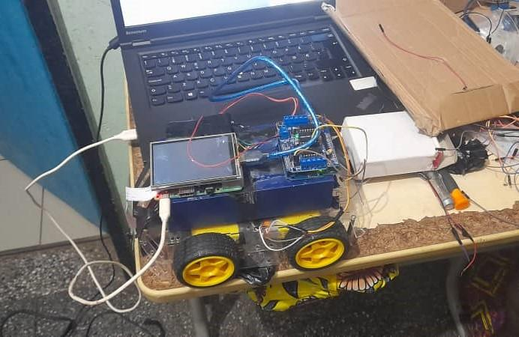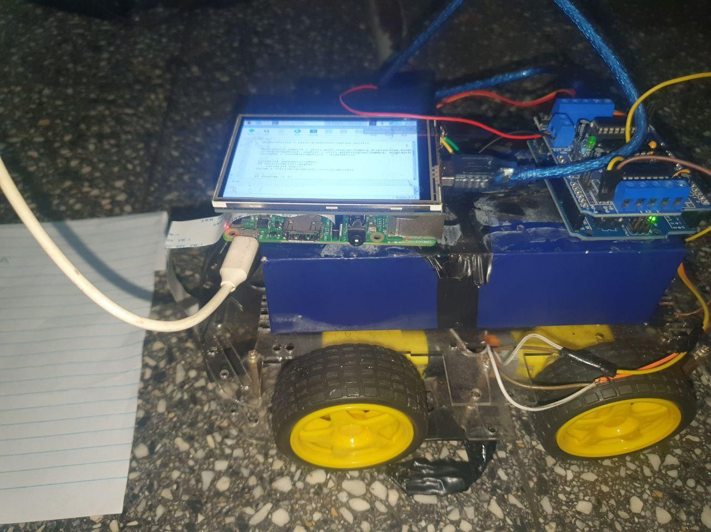

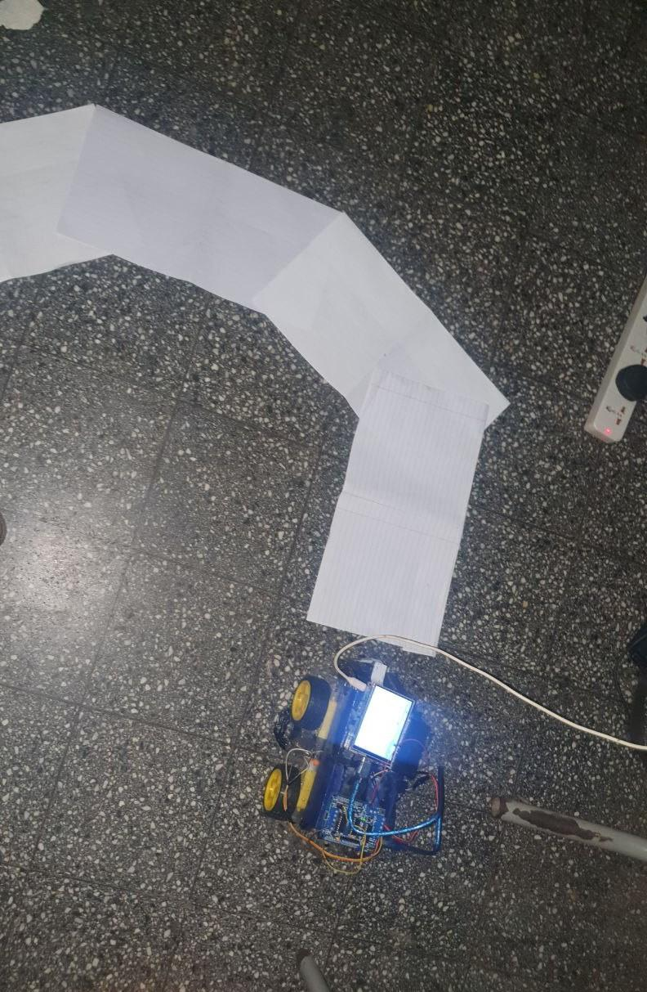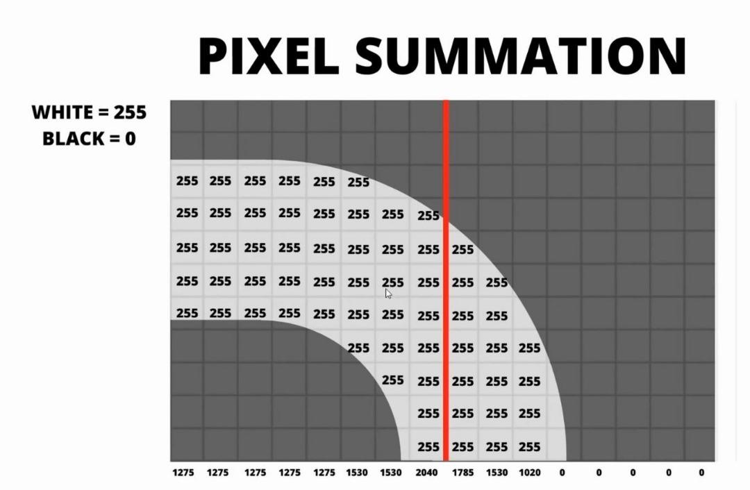

# **References**

[1] <https://www.st.com/en/microcontrollers-microprocessors/stm32h743-753/documentation.html>

[2] <https://projects.raspberrypi.org/en/projects/raspberry-pi-getting-started>

[3] <https://www.st.com/en/motor-drivers/l293d.html>

[4] <https://www.instructables.com/Arduino-L293D-Motor-Driver-Shield-Tutorial/>

[5] <https://www.instructables.com/Raspberry-Pi-Arduino-Serial-Communication/#:~:text=In%20common%2C%20the%20connections%20are,you%20are%20good%20to%20go>.

[6] <https://www.researchgate.net/figure/Pixel-Summation-Output_fig2_353773538#:~:text=Lane%20detection%20is%20a%20developing,on%20the%20existence%20of%20markings>.